
FACULTY OF ENGINEERING AND TECHNOLOGY

Enterprise Programming using Java
Laboratory
(303105310)

5th SEMESTER
Computer Science & Engineering Department
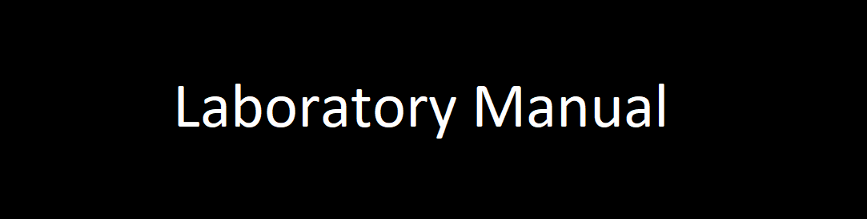
A.Y 2025-26
Submitted to :

Ajay Duddi
Submitted by :

Name : Anand Shekhar
Enroll. No. : 2303051050080
Division : 5A1
Roll No. : 34

CERTIFICATE

This is to certify that
Mr. ANAND SHEKHAR with enrollment no. 2303051050080 has successfully completed his/her laboratory experiments in the Enterprise Programming using Java Laboratory (303105310) from the department of COMPUTER SCIENCE & ENGINEERING during the academic year 2025-2026.


Date of Submission : ......................... Staff In charge : ..............................

Head Of Department:...........................................

TABLE OF CONTENTS
Sr. No | Experiment Title | Page No |  | Date of Start | Date of Completion | Sign | Marks (out of 10)
Sr. No | Experiment Title | From | To
1. | Write a program to insert and retrieve the data from database using JDBC.
2. | Write a program to demonstrate the use of Prepared Statement and Result Set interface.
3. | Servlet Programming :  Servlet Execution on tomcat A servlet program to print hello world.  A servlet program to display request details A servlet program to handle user form.  A servlet program to create a cookie A servlet program to display cookie .  A servlet program to do session tracking .  Write a program to implement chat Server using Server Socket  Write a Servlet program to send username and password using HTML forms and authenticate the user
4. | JSP Programming  JSP program to display helloworld. JSP program to demonstrate arithmetic operations.  JSP program to demonstrate jsp: forward action tag JSP program to request implicit object Developing a web application to insert record into Oracle Database using JSP and JDBC
5. | Create application to store the data in database to perform Hibernate CRUD operations.
6. | Create a application store the data in database to perform Spring CRUD operations.
7. | Create a web application to store the data in database with spring boot.

Practical-01:
AIM: Write a program to insert and retrieve the data from a MySQL data-
base using Java Database Connectivity (JDBC).
Theory:
Understanding the JDBC Standard

The Java Database Connectivity (JDBC) API is the standard tool for connecting Java applications to relational database systems. It provides the necessary framework (classes and interfaces) for sending SQL commands from a Java environment and processing the responses.
A standard JDBC execution involves these key phases:
- Loading the Necessary Driver: The specific database driver, like the com.mysql.cj.jdbc.Driver for MySQL, is loaded into the Java Virtual Machine's memory.
- Creating a Connection: A connection URL, along with valid user credentials, is passed to the DriverManager to open a direct, physical link to the database server.
- Issuing SQL Commands:
  - PreparedStatement is utilized for safe and efficient data insertion (DML), drastically lowering the risk of SQL Injection.
  - The basic Statement is used for tasks like table creation (DDL) and data retrieval (DQL), with query results being held by a ResultSet.
- Managing Resources: Employing a modern Java construct like try-with-resources ensures that all acquired database objects (the connection, statements, and result sets) are reliably and automatically closed, which is vital for system stability.

Steps:

1.Create the table:
CREATE TABLE students
( id SERIAL PRIMARY KEY,
name VARCHAR(100) NOT NULL,
email VARCHAR(100) UNIQUE,
age INTEGER);

2. Open Eclispe (Enterprise Web Developers) and create Java Project
(File>New>JavaProject) and create Class.

3. After creating the Class, Configure the postgresSql Connector jar file
(Buildpath>configure build path>libraries>classpath>AddExternal Jars and add the file
CODE:
package com.enterprise.jdbc;

import java.sql.Connection;
import java.sql.DriverManager;
import java.sql.ResultSet;
import java.sql.SQLException;
import java.sql.Statement;

public class practical_one {
public static void main(String[] args) {
String url = "jdbc:postgresql://localhost:5432/enterprise";
String username = "anand";
String password = "java";

Connection conn = null;
Statement stmt = null;
ResultSet rs = null;

try {

Class.forName("org.postgresql.Driver");
System.out.println("PostgreSQL Driver registered successfully.");

conn = DriverManager.getConnection(url, username, password);
System.out.println("Connected to PostgreSQL successfully!");

stmt = conn.createStatement();

String studentName = "Anand";
String studentEmail = "Anand@example.com";
int studentAge = 21;

String insertSQL = "INSERT INTO students(name, email, age) VALUES ('" + studentName + "', '" + studentEmail + "', " + studentAge + ")";
int rowsInserted = stmt.executeUpdate(insertSQL);
System.out.println(rowsInserted + " row(s) inserted.");

String selectSQL = "SELECT id, name, email, age FROM students";
rs = stmt.executeQuery(selectSQL);

System.out.println("\n----------- Student Records -----------");
while (rs.next()) {
int id = rs.getInt("id");
String name = rs.getString("name");
String email = rs.getString("email");
int age = rs.getInt("age");

System.out.println("ID: " + id + " | Name: " + name + " | Email: " + email + " | Age: " + age);
}
System.out.println("---------------------------------------");

} catch (ClassNotFoundException e) {
System.err.println("PostgreSQL driver not found.");
e.printStackTrace();
}
Finally{
if (rs != null) rs.close();
if (stmt != null) stmt.close();
if (conn != null) conn.close();
System.out.println("Resources closed successfully.");
}
OUTPUT:

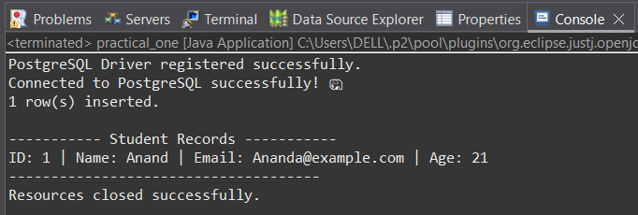

Practical-02:
Aim: Write a program to demonstrate the use of the PreparedStatement
and ResultSet interfaces for dynamic data retrieval from a database.
Theory:
Understanding Key JDBC Interfaces
The PreparedStatement Interface

This interface is an extension of Statement designed specifically for running parameterized SQL statements. Unlike its predecessor, the core benefits of PreparedStatement are:
- Optimized Performance (Pre-Compilation): The underlying database only needs to compile the SQL query one time when the statement object is created. This single compilation drastically speeds up execution, particularly for queries that are run multiple times.
- Enhanced Security (SQL Injection Defense): It is the primary tool for preventing SQL Injection because it automatically and correctly escapes any special characters found in the input data. Developers use question marks (?) as placeholders in the SQL string, and then assign values to these placeholders using appropriate, type-specific setter methods (e.g., setInt(), setString()).
The ResultSet Interface
The ResultSet object serves as a container for the tabular data returned by a SELECT query. Conceptually, it functions as an iterator that maintains a cursor pointing to the currently active row of data.
- Row Iteration: The next() method is used to advance the cursor to the subsequent row. Since next() returns a true value if a new row exists, a common and effective pattern is to use a while (rs.next()) loop to iterate through every record retrieved.
- Data Access: Data from the row currently pointed to by the cursor is extracted using type-safe getter methods (e.g., getInt(), getString()). Columns can be referenced either by their name (e.g., getInt("id")) or their numerical index.
CODE:
package com.enterprise.jdbc;

import java.sql.Connection;
import java.sql.DriverManager;
import java.sql.PreparedStatement;
import java.sql.ResultSet;
import java.sql.SQLException;
import java.sql.Statement;
import java.util.Scanner;

public class PreparedStatementDemo {

private static final String JDBC_URL = "jdbc:postgresql://localhost:5432/enterprise";
private static final String USERNAME = "anand";
private static final String PASSWORD = "java";

public static void main(String[] args) {
try (Connection connection = DriverManager.getConnection(JDBC_URL, USERNAME, PASSWORD);
Scanner scanner = new Scanner(System.in)) {

System.out.println("Connected to PostgreSQL database successfully! ");
createTableIfNotExists(connection);

while (true) {
System.out.println("\n----------- MENU -----------");
System.out.println("1. Insert New Student");
System.out.println("2. View All Students");
System.out.println("3. Exit");
System.out.print("Enter your choice: ");

int choice = scanner.nextInt();
scanner.nextLine();

switch (choice) {
case 1:
insertStudent(connection, scanner);
break;
case 2:
queryStudents(connection);
break;
case 3:
System.out.println("Exiting program..");
return;
default:
System.out.println("Invalid choice. Please try again.");
}
}
} catch (SQLException e) {
System.err.println("Database connection error!");
e.printStackTrace();
}
}

public static void createTableIfNotExists(Connection connection) throws SQLException {
String createTableSQL = "CREATE TABLE IF NOT EXISTS students ("
+ "id SERIAL PRIMARY KEY, "
+ "name VARCHAR(100) NOT NULL, "
+ "email VARCHAR(100) UNIQUE NOT NULL, "
+ "age INT"
+ ")";
public static void insertStudent(Connection connection, Scanner scanner) throws SQLException {
System.out.println("\n--- Enter New Student Details ---");
System.out.print("Enter name: ");
String name = scanner.nextLine();
System.out.print("Enter email: ");
String email = scanner.nextLine();
System.out.print("Enter age: ");
int age = scanner.nextInt();
scanner.nextLine(); // Consume newline

String insertSQL = "INSERT INTO students(name, email, age) VALUES (?, ?, ?)";

try (PreparedStatement pstmt = connection.prepareStatement(insertSQL)) {
pstmt.setString(1, name);
pstmt.setString(2, email);
pstmt.setInt(3, age);

int rowsAffected = pstmt.executeUpdate();
if (rowsAffected > 0) {
System.out.println("Student added successfully! \uD83D\uDE0A");
}
}
}
public static void queryStudents(Connection connection) throws SQLException {
System.out.println("\n----------- All Student Records -----------");
String querySQL = "SELECT id, name, email, age FROM students ORDER BY id";

try (Statement stmt = connection.createStatement();
ResultSet rs = stmt.executeQuery(querySQL)) {

boolean found = false;
while (rs.next()) {
found = true;
int id = rs.getInt("id");
String name = rs.getString("name");
String email = rs.getString("email");
int age = rs.getInt("age");

System.out.printf("ID: %-4d | Name: %-20s | Email: %-25s | Age: %d%n", id, name, email, age);
}
if (!found) {
System.out.println("No students found in the database.");
}
}
System.out.println("-------------------------------------------");
}

OUTPUT:
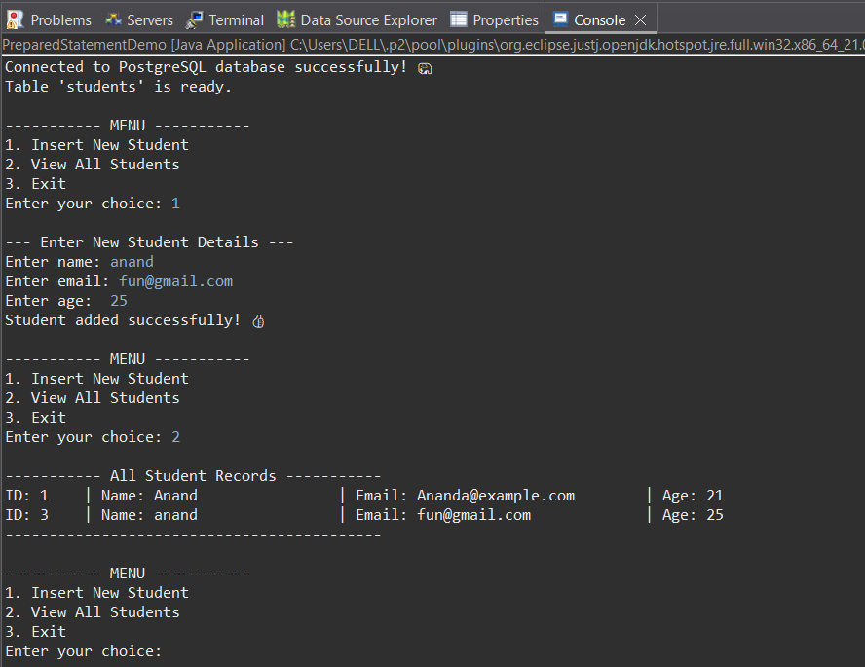
Practical-03:
Aim:
1. Servlet execution, Hello World, and displaying request details.
2. A servlet program to display request details and handle user form.
3. Demonstrating state management using Cookies and Session Tracking.
4. Implementing a basic Chat Server using ServerSocket and Socket
classes.
5. A Servlet program to send username and password using HTML forms and authenticate the user.

Theory:
TOMCAT SERVER:
Tomcat provides a pure Java environment where Java code can execute to generate dynamic web content.
- Servlet Container: This is Tomcat's core function. It implements the official Jakarta Servlet and Jakarta Server Pages (JSP) specifications (formerly Java EE/Java Enterprise Edition). It manages the lifecycle of Java Servlets (Java programs that process client requests) and renders JSPs (HTML pages with embedded Java code) into executable Servlets.
- Web Server (HTTP Connector): Tomcat includes a component called Coyote that acts as an HTTP web server. This allows Tomcat to listen for and handle incoming HTTP requests from clients (like web browsers) and send back the HTTP responses.
Configuration of tomcat server:
Steps invoved:
1. Create Dynamic web Project (file>new>other>dwp) and give class name.
2. Install Apache Tomcat.
3. Configure servlet api jar file in the project
(Buildpath>configure buildpath>downloads>apachetomacat>lib>servlet
api)
4. Configure apache tomcat server .
(Run on server > choose version of tomcat in Apache> browse the
path and select jre version and run) and start the server.
Servlet Execution on tomcat.
➢ Install Tomcat (e.g., Apache Tomcat 10.1).
➢ Add servlet-api.jar to your project’s classpath (comes with Tomcat in lib
folder).
➢ Create your Java servlet program inside src folder of a Dynamic Web
Project in Eclipse (or manually in Tomcat’s WEB-INF/classes).
➢ Configure web.xml OR use @WebServlet annotation.
➢ Deploy WAR to Tomcat’s webapps folder and start Tomcat.
3.1 Servlet execution, Hello World, and displaying request details.
Theory:
Servlet:
A Servlet is a Java class used to extend the capabilities of a server (typically a web server) by generating dynamic content for web applications. They are the fundamental building blocks of server-side Java web technology.

CODE:
package firstpackage;

import java.io.IOException;
import java.io.PrintWriter;

import jakarta.servlet.annotation.WebServlet;
import jakarta.servlet.http.HttpServlet;
import jakarta.servlet.http.HttpServletRequest;
import jakarta.servlet.http.HttpServletResponse;

@WebServlet("/hello")
public class HelloServlet extends HttpServlet {
public void doGet(HttpServletRequest req, HttpServletResponse res) throws IOException {
res.setContentType("text/html");
PrintWriter out = res.getWriter();
out.println("<h1>Hello from Servlet,Anand</h1>");
}
}

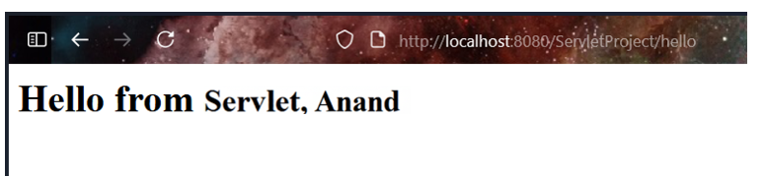
OUTPUT:

3.2 A servlet program to display request details and handle user form.

CODE:
package firstpackage;

import java.io.IOException;
import java.io.PrintWriter;

import jakarta.servlet.ServletException;
import jakarta.servlet.annotation.WebServlet;
import jakarta.servlet.http.HttpServlet;
import jakarta.servlet.http.HttpServletRequest;
import jakarta.servlet.http.HttpServletResponse;

@WebServlet("/RequestDetails")
public class RequestDetailsServlet extends HttpServlet {
protected void doGet(HttpServletRequest request, HttpServletResponse response)
throws ServletException, IOException {
response.setContentType("text/html");
PrintWriter out = response.getWriter();

out.println("<h2>Request Details</h2>");
out.println("Method: " + request.getMethod() + "<br>");
out.println("Request URI: " + request.getRequestURI() + "<br>");
out.println("Protocol: " + request.getProtocol() + "<br>");
out.println("Remote Address: " + request.getRemoteAddr() + "<br>");
out.println("IP Address: " + request.getRemoteAddr());
}
}
OUTPUT:
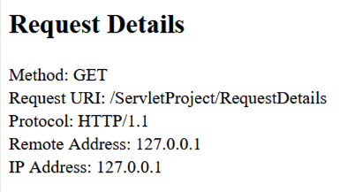

HANDLE USER FORM:
CODE:
Form.html
<!DOCTYPE html>
<html>
<head>
<title>User Form</title>
</head>
<body>

<h2>User Form</h2>
<form action="formHandler" method="post">
Name: <input type="text" name="username"><br><br>
Email: <input type="email" name="email"><br><br>
<input type="submit" value="Submit">
</form>

</body>
</html>

FormHandlerServlet.java
package firstpackage;

import java.io.IOException;
import java.io.PrintWriter;

import jakarta.servlet.annotation.WebServlet;
import jakarta.servlet.http.HttpServlet;
import jakarta.servlet.http.HttpServletRequest;
import jakarta.servlet.http.HttpServletResponse;

@WebServlet("/formHandler")
public class FormHandlerServlet extends HttpServlet {

@Override
protected void doPost(HttpServletRequest request, HttpServletResponse response) throws IOException {
response.setContentType("text/html");
PrintWriter out = response.getWriter();

String username = request.getParameter("username");
String email = request.getParameter("email");

out.println("<html><body>");
out.println("<h2>Submitted Successfully</h2>");
out.println("<p><strong>Name:</strong> " + username + "</p>");
out.println("<p><strong>Email:</strong> " + email + "</p>");
out.println("</body></html>");
}

@Override
protected void doGet(HttpServletRequest request, HttpServletResponse response) throws IOException {
// Redirect to the form if someone tries to access the servlet directly
response.sendRedirect("form.html");
}
}
OUTPUT:
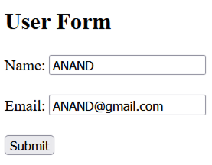
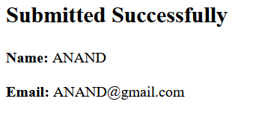
3.3 Demonstrating state management using Cookies and Session Tracking
Theory:

Cookies:
A cookie is a small piece of data that a server sends to a user's web browser. The browser stores it and sends it back to the same server with every subsequent request.

Session Tracking:
It is a server-side technique. When you first visit a site, the server creates a unique, random ID for you called a session ID. The server stores all your information (like who you are and what's in your cart) on its side, linked to this ID.
CODE:
CookieCreateServlet.java
package firstpackage;

import java.io.IOException;
import java.io.PrintWriter;
import java.time.LocalDateTime;

import jakarta.servlet.annotation.WebServlet;
import jakarta.servlet.http.Cookie;
import jakarta.servlet.http.HttpServlet;
import jakarta.servlet.http.HttpServletRequest;
import jakarta.servlet.http.HttpServletResponse;

@WebServlet("/create-cookie")
public class CookieCreateServlet extends HttpServlet {
protected void doGet(HttpServletRequest request, HttpServletResponse response) throws IOException {

Cookie visitCookie = new Cookie("lastVisit", LocalDateTime.now().toString());

visitCookie.setMaxAge(60 * 60 * 24 * 30);

response.addCookie(visitCookie);

response.setContentType("text/html");
PrintWriter out = response.getWriter();
out.println("<html><body>");
out.println("<h1>Cookie Created</h1>");
out.println("<p>A cookie named 'lastVisit' has been sent to your browser.</p>");
out.println("<p><a href='display-cookie'>View Cookies</a></p>");
out.println("</body></html>");
}
}
CookieDisplayServlet.java
package firstpackage;

import java.io.IOException;
import java.io.PrintWriter;

import jakarta.servlet.annotation.WebServlet;
import jakarta.servlet.http.Cookie;
import jakarta.servlet.http.HttpServlet;
import jakarta.servlet.http.HttpServletRequest;
import jakarta.servlet.http.HttpServletResponse;

@WebServlet("/display-cookie")
public class CookieDisplayServlet extends HttpServlet {
protected void doGet(HttpServletRequest request, HttpServletResponse response) throws IOException {
response.setContentType("text/html");
PrintWriter out = response.getWriter();
out.println("<html><body>");
out.println("<h2>Your Cookies</h2>");

Cookie[] cookies = request.getCookies();

if (cookies != null && cookies.length > 0) {
out.println("<table border=1><tr><th>Cookie Name</th><th>Cookie Value</th></tr>");

for (Cookie cookie : cookies) {
out.println("<tr><td>" + cookie.getName() + "</td><td>" + cookie.getValue() + "</td></tr>");
}
out.println("</table>");
} else {
out.println("<p>No cookies found.</p>");
}

out.println("<br><a href='create-cookie'>Create New Cookie</a>");
out.println("</body></html>");
}
}
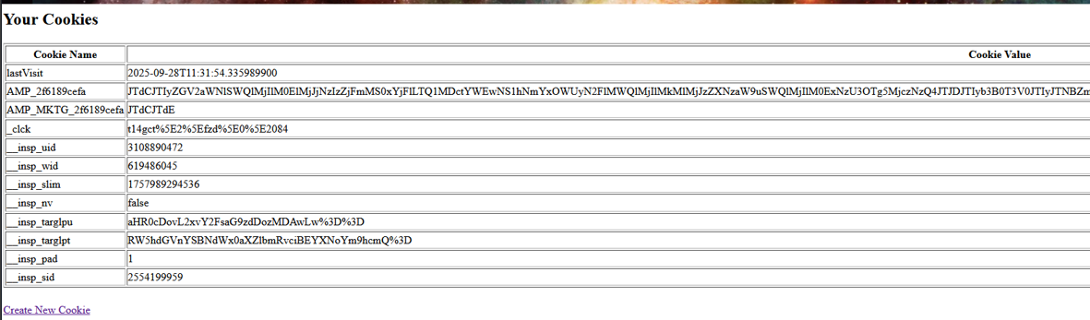
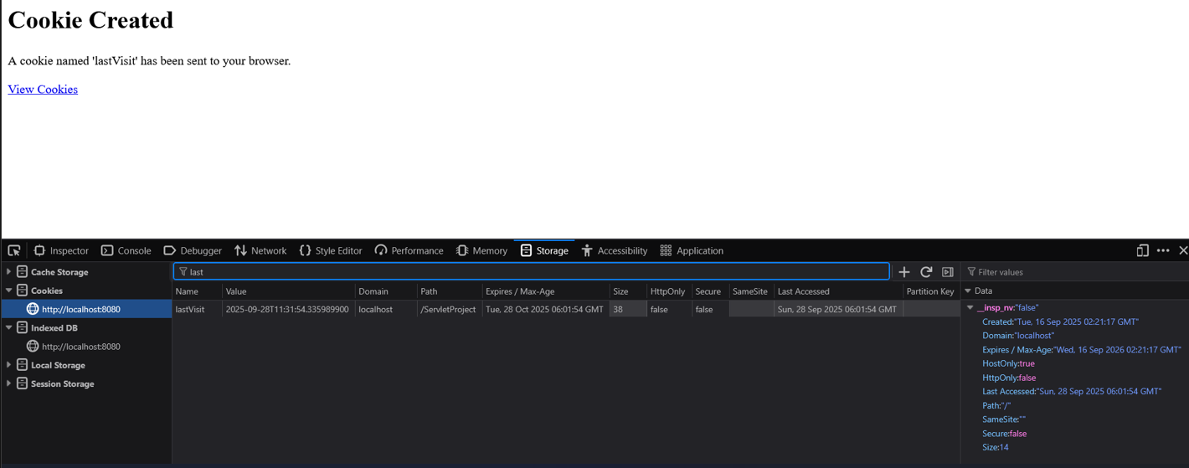
OUTPUT:
Session Tracking:
CODE:
package firstpackage;

import java.io.IOException;
import java.io.PrintWriter;

import jakarta.servlet.*;
import jakarta.servlet.annotation.WebServlet;
import jakarta.servlet.http.*;

@WebServlet("/session-track")
public class SessionTrackingServlet extends HttpServlet {
protected void doGet(HttpServletRequest request, HttpServletResponse response)
throws ServletException, IOException {

response.setContentType("text/html");
PrintWriter out = response.getWriter();

HttpSession session = request.getSession(true);

Integer visitCount = (Integer) session.getAttribute("visitCount");

if (visitCount == null) {
visitCount = 1;
} else {
visitCount++;
}

session.setAttribute("visitCount", visitCount);

out.println("<html><body>");
out.println("<h1>Session Tracking Demo</h1>");
out.println("<p>Session ID: " + session.getId() + "</p>");
out.println("<p>Number of visits: " + visitCount + "</p>");
out.println("<p>Session created at: " + session.getCreationTime() + "</p>");
out.println("<p>Last accessed at: " + session.getLastAccessedTime() + "</p>");
out.println("</body></html>");

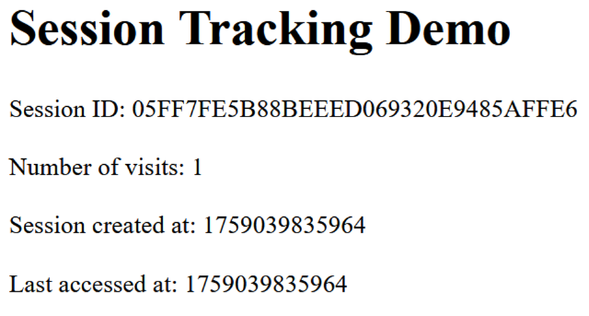

3.4 Implementing a basic Chat Server using ServerSocket and Socket
classes.
➢ Server Socket Flow
• Starts server on port 5000
• Waits for client connection using serverSocket.accept()
• Sets up streams for input/output communication
• Enters loop to continuously exchange messages:
o Reads client message from input stream
o Checks for exit condition ("bye" message)
o Displays client message on console
o Reads server response from console input
o Sends response back to client
• Closes connections when client disconnects
➢ Client Socket Flow
• Connects to server at localhost:5000
• Enters loop to continuously exchange messages:
o Reads user input from console
o Sends message to server
o Checks for exit condition ("bye" message)
o Reads server response from input stream
o Displays server message on console
• Closes connection when exiting.
CODE:
ChatServer.java : Server Socket
package firstpackage;

import java.io.BufferedReader;
import java.io.IOException;
import java.io.InputStreamReader;
import java.io.PrintWriter;
import java.net.ServerSocket;
import java.net.Socket;

public class chatServer {
public static void main(String[] args) throws IOException {
ServerSocket serverSocket = new ServerSocket(5000);
System.out.println("Chat Server started on port 5000...");

Socket socket = serverSocket.accept();
System.out.println("Client connected.");

BufferedReader in = new BufferedReader(new InputStreamReader(socket.getInputStream()));
PrintWriter out = new PrintWriter(socket.getOutputStream(), true);

BufferedReader console = new BufferedReader(new InputStreamReader(System.in));

String msg;
while (true) {

if ((msg = in.readLine()) != null) {
if (msg.equalsIgnoreCase("bye")) {
System.out.println("Client disconnected.");
break;
}
System.out.println("Client: " + msg);
}

System.out.print("You: ");
out.println(console.readLine());
}
}
}
ChatClient.java : Client Socket
CODE:
import java.io.BufferedReader;
import java.io.IOException;
import java.io.InputStreamReader;
import java.io.PrintWriter;
import java.net.Socket;

public class chatclient {
public static void main(String[] args) throws IOException {

Socket socket = new Socket("localhost", 5000);
System.out.println("Connected to the chat server.");

BufferedReader in = new BufferedReader(new InputStreamReader(socket.getInputStream()));

PrintWriter out = new PrintWriter(socket.getOutputStream(), true);

BufferedReader console = new BufferedReader(new InputStreamReader(System.in));

String msg;
while (true) {
System.out.print("You: ");
msg = console.readLine();

out.println(msg);

if (msg.equalsIgnoreCase("bye")) {
System.out.println("Disconnecting from server.");
break;
}

System.out.println("Server: " + in.readLine());
}

socket.close();
}
}
OUTPUT:
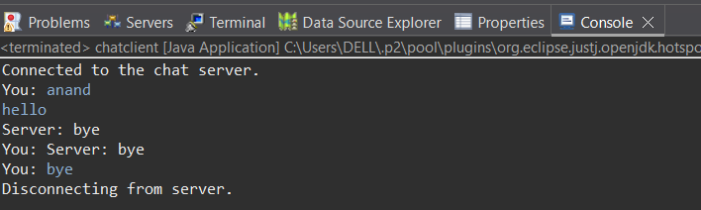
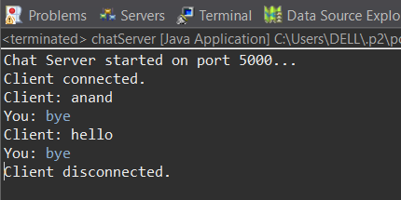

3.5 A Servlet program to send username and password using HTML forms and authenticate the user.
➢ login.html
<!DOCTYPE html>
<html lang="en">
<head>
<meta charset="UTF-8">
<meta name="viewport" content="width=device-width, initial-scale=1.0">
<title>Login - Secure Access</title>
<link rel="stylesheet" href="css/login.css">
</head>
<body>

<div class="login-container">
<div class="login-header">
<h1>Secure Login</h1>
<p>Please enter your credentials to continue</p>
</div>

<div class="error-message" id="errorMessage">
Invalid username or password. Please try again.
</div>

<form action="login" method="POST" id="loginForm">
<div class="form-group">
<label for="username">Username</label>
<input type="text" id="username" name="username" placeholder="Enter your username" required>
</div>

<div class="form-group">
<label for="password">Password</label>
<input type="password" id="password" name="password" placeholder="Enter your password" required>
</div>

<button type="submit" class="btn-login">Login</button>
</form>

<script src="js/login.js"></script>
</div>

</body>
</html>

Welcome.html
<!DOCTYPE html>
<html lang="en">
<head>
<meta charset="UTF-8">
<meta name="viewport" content="width=device-width, initial-scale=1.0">
<title>Welcome - Dashboard</title>
<link rel="stylesheet" href="css/welcome.css">
</head>
<body>

<div class="welcome-container">
<div class="welcome-icon"></div>
<div class="welcome-header">
<h1>Welcome Back!</h1>
</div>

<div class="welcome-message">
<p>You have successfully logged in to your account.</p>
<p>We're glad to see you again!</p>
</div>

<div class="user-info">
<h3>User Information</h3>
<p><strong>Username:</strong> <span id="username"></span></p>
<p><strong>Login Time:</strong> <span id="loginTime"></span></p>
<p><strong>Status:</strong> Active Session</p>
</div>

<a href="logout" class="btn-logout">Logout</a>

<script src="js/welcome.js"></script>
</div>

</body>
</html>
LoginServelet.java
CODE:
import java.io.*;
import jakarta.servlet.*;
import jakarta.servlet.annotation.WebServlet;
import jakarta.servlet.http.*;

@WebServlet("/login")
public class LoginServlet extends HttpServlet {
private static final String VALID_USERNAME = "admin";
private static final String VALID_PASSWORD = "password123";

protected void doGet(HttpServletRequest request, HttpServletResponse response)
throws ServletException, IOException {
response.sendRedirect("login.html");
}

protected void doPost(HttpServletRequest request, HttpServletResponse response)
throws ServletException, IOException {

String username = request.getParameter("username");
String password = request.getParameter("password");

if (VALID_USERNAME.equals(username) && VALID_PASSWORD.equals(password)) {
HttpSession session = request.getSession(true);
session.setAttribute("username", username);
response.sendRedirect("welcome.html");
} else {
response.setContentType("text/html");
PrintWriter out = response.getWriter();
out.println("<html><body>");
out.println("<h3 style=\"color:red;\">Login Failed</h3>");
out.println("<p>Invalid username or password. <a href=\"login.html\">Try again</a></p>");
out.println("</body></html>");
}
}
}

LogoutServlet.java
CODE:
package web_page_nine;

import java.io.*;
import jakarta.servlet.*;
import jakarta.servlet.annotation.WebServlet;
import jakarta.servlet.http.*;

@WebServlet("/logout")
public class LogoutServlet extends HttpServlet {
protected void doGet(HttpServletRequest request, HttpServletResponse response)
throws ServletException, IOException {

HttpSession session = request.getSession(false);

if (session != null) {
session.invalidate();
}

response.setContentType("text/html");
PrintWriter out = response.getWriter();
out.println("<html><body>");
out.println("<h1>You have been logged out</h1>");
out.println("<a href=\"login.html\">Login again</a>");
out.println("</body></html>");
}
}
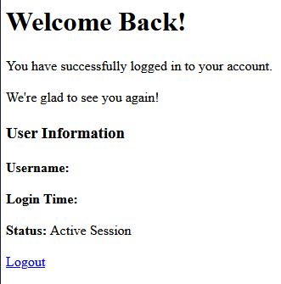
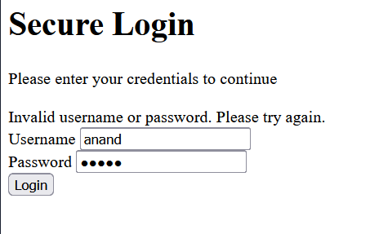
OUTPUT:

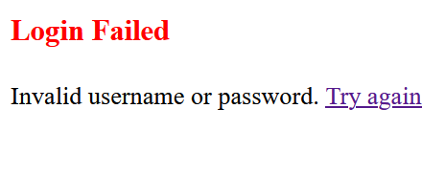

Practical-04:
AIM:
Implement comprehensive JSP Programming concepts, including:

1. Basic JSP programming (Hello World, Arithmetic Operations).
2. Demonstration of the jsp:forward action tag.
3. Utilizing JSP Implicit Objects (e.g., request, out).
4. Developing a web application to insert records into Oracle Database using JSP and JDBC.
Theory:
JSP is a technology for building dynamic web pages that can show different content based on user actions or data from a database. Think of it as HTML with superpowers. It lets you write regular HTML for the page layout and then embed Java code directly inside special tags (<% ... %>) to add logic.
Behind the scenes, when a user requests a JSP file for the first time, the web server (like Tomcat) automatically translates the entire JSP file into a standard Java Servlet. This means you get the power of Servlets without having to write all the Java code for generating HTML manually.

3.1 Basic JSP programming (Hello World, Arithmetic Operations).
CODE:
<%@ page language="java" contentType="text/html; charset=UTF-8" pageEncoding="UTF-8"%>
<!DOCTYPE html>
<html>
<head>
<title>Hello JSP</title>
</head>
<body>

<h1>Hello World from JSP!Anand</h1>

<p>This page was generated on: <%= new java.util.Date() %></p>

</body>
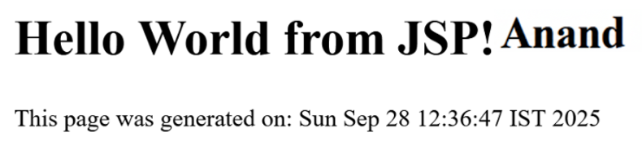
</html>
OUTPUT
CODE(Arithematic Operation):
CODE:
<%@ page language="java" contentType="text/html; charset=UTF-8" pageEncoding="UTF-8"%>
<!DOCTYPE html>
<html>
<head>
<title>Arithmetic Operations</title>
</head>
<body>

<h1>Arithmetic Operations Anand</h1>

<%
int a = 20;
int b = 5;
%>

<table border="1">
<tr>
<th>Operation</th>
<th>Result</th>
</tr>

<tr>
<td>Addition</td>
<td><%= a + b %></td>
</tr>

<tr>
<td>Subtraction</td>
<td><%= a - b %></td>
</tr>

<tr>
<td>Multiplication</td>
<td><%= a * b %></td>
</tr>

<tr>
<td>Division</td>
<td><%= a / b %></td>
</tr>

<tr>
<td>Modulus</td>
<td><%= a % b %></td>
</tr>

</table>
</body>
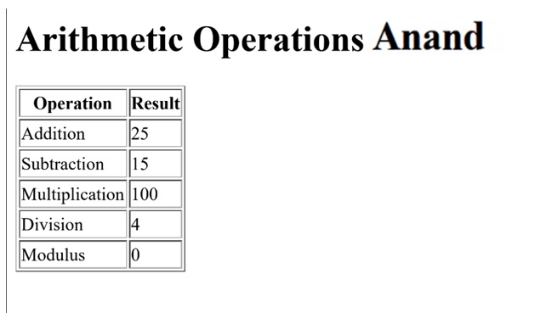
</html>
OUTPUT:
3.4 and 3.5: using implicit jsp object and developing a web application to insert records into Oracle Database using JSP and JDBC.
CODE:
Insert_Record.jsp :
<%@ page language="java" contentType="text/html; charset=UTF-8" pageEncoding="UTF-8"%>
<%@ page import="java.sql.*, java.util.Date" %>

<%!
// Static final variables for student and database details
private static final String STUDENT_NAME = "Anand Shekhar";
private static final String ENROLLMENT_NO = "2303051050080";
private static final String DIVISION = "5A1";
private static final String DRIVER = "oracle.jdbc.driver.OracleDriver";
private static final String URL = "jdbc:oracle:thin:@localhost:1521:xe";
private static final String USER = "system";
private static final String PASS = "oracle_password";
%>

<%
// --- Server-side Java Logic for Handling Form Submission ---
String empIdStr = request.getParameter("empId");
String name = request.getParameter("name");
String salaryStr = request.getParameter("salary");

// This block executes only when the form is submitted (all parameters are present)
if (empIdStr != null && name != null && salaryStr != null) {
Connection con = null;
PreparedStatement ps = null;

try {
Class.forName(DRIVER);
con = DriverManager.getConnection(URL, USER, PASS);

// Create table if it doesn't exist (simple approach for this practical)
try (Statement stmt = con.createStatement()) {
stmt.execute("CREATE TABLE EMPLOYEE_RECORDS (ID NUMBER PRIMARY KEY, NAME VARCHAR2(100), SALARY NUMBER)");
} catch (SQLException e) {
// Table already exists, which is fine. Ignore this specific error.
}

// Insert the new record using a PreparedStatement to prevent SQL injection
String sql = "INSERT INTO EMPLOYEE_RECORDS (ID, NAME, SALARY) VALUES (?, ?, ?)";
ps = con.prepareStatement(sql);

int empId = Integer.parseInt(empIdStr);
double salary = Double.parseDouble(salaryStr);

ps.setInt(1, empId);
ps.setString(2, name);
ps.setDouble(3, salary);

int rowsAffected = ps.executeUpdate();

// Set a success message to be displayed on the forwarded page
request.setAttribute("message", "Success: " + rowsAffected + " record(s) inserted.");

// Forward the request to the display page
%>
<jsp:forward page="Display_Records.jsp" />
<%
} catch (ClassNotFoundException e) {
request.setAttribute("error", "Error: JDBC Driver not found. Check Oracle JAR file.");
} catch (SQLException e) {
request.setAttribute("error", "Error: Database problem. SQL State: " + e.getSQLState());
} catch (NumberFormatException e) {
request.setAttribute("error", "Error: Employee ID and Salary must be valid numbers.");
} finally {
try {
if (ps != null) ps.close();
if (con != null) con.close();
} catch (SQLException e) {
// Ignore closing errors
}
}
}
%>

<!DOCTYPE html>
<html>
<head>
<meta charset="UTF-8">
<title>Practical 4 - Record Insertion</title>
<style>
body { font-family: Arial, sans-serif; background-color: #f0f4f8; padding: 20px; }
.container { max-width: 600px; margin: 30px auto; background: white; padding: 30px; border-radius: 10px; box-shadow: 0 4px 12px rgba(0,0,0,0.1); }
h1 { color: #D32F2F; border-bottom: 2px solid #D32F2F; padding-bottom: 10px; margin-bottom: 20px; }
label { display: block; margin-bottom: 8px; font-weight: bold; color: #555; }
input[type="text"] { width: 100%; padding: 10px; margin-bottom: 20px; border: 1px solid #ccc; border-radius: 5px; box-sizing: border-box; }
button { background-color: #D32F2F; color: white; padding: 12px 20px; border: none; border-radius: 5px; cursor: pointer; font-size: 16px; }
.verification { margin-top: 20px; padding: 10px; border: 1px dashed #4CAF50; background-color: #E8F5E9; font-weight: bold; }
.error { color: #E53935; background-color: #FFEBEE; padding: 10px; border: 1px solid #E57373; margin-top: 15px; border-radius: 4px; }
.demo-box { background-color: #f9f9f9; padding: 15px; border-radius: 5px; margin-bottom: 20px; border: 1px dashed #ccc;}
</style>
</head>
<body>
<div class="container">

<%-- Display error message if insertion failed --%>
<% if (request.getAttribute("error") != null) { %>
<div class="error">
Insertion Failed: <%= request.getAttribute("error") %>
</div>
<% } %>

<div class="demo-box">
<h3>Implicit Object Demo</h3>
<p><b>Request IP Address (from `request` object):</b> <%= request.getRemoteAddr() %></p>
</div>

<form method="POST">
<label for="empId">Employee ID (Number):</label>
<input type="text" id="empId" name="empId" required value="103">

<label for="name">Employee Name (String):</label>
<input type="text" id="name" name="name" required value="<%= STUDENT_NAME %>">

<label for="salary">Employee Salary (Number):</label>
<input type="text" id="salary" name="salary" required value="85000">

<button type="submit">Insert Record & Forward</button>
</form>

<div class="verification">
Verification: Name: <%= STUDENT_NAME %> | Enrollment: <%= ENROLLMENT_NO %> | Division: <%= DIVISION %>
</div>
</div>
</body>
</html>
Display_Records.jsp
<%@ page language="java" contentType="text/html; charset=UTF-8" pageEncoding="UTF-8"%>
<%@ page import="java.sql.*" %>

<%!
// Static final variables for student and database details
private static final String STUDENT_NAME = "Subhadeep Roy";
private static final String ENROLLMENT_NO = "2303051050922";
private static final String DIVISION = "5A1";
private static final String DRIVER = "oracle.jdbc.driver.OracleDriver";
private static final String URL = "jdbc:oracle:thin:@localhost:1521:xe";
private static final String USER = "system";
private static final String PASS = "oracle_password";
%>

<!DOCTYPE html>
<html>
<head>
<meta charset="UTF-8">
<title> Display Records</title>
<style>
body { font-family: Arial, sans-serif; background-color: #e8f5e9; padding: 20px; }
.container { max-width: 800px; margin: 30px auto; background: white; padding: 30px; border-radius: 10px; box-shadow: 0 4px 12px rgba(0,0,0,0.1); }
h1 { color: #4CAF50; border-bottom: 2px solid #81C784; padding-bottom: 10px; margin-bottom: 20px; }
h2 { color: #66BB6A; margin-top: 20px; }
table { width: 100%; border-collapse: collapse; margin-top: 15px; }
th, td { border: 1px solid #ddd; padding: 10px; text-align: left; }
th { background-color: #C8E6C9; }
.verification { margin-top: 20px; padding: 10px; border: 1px dashed #D32F2F; background-color: #FFEBEE; font-weight: bold; }
.demo-box { background-color: #F1F8E9; padding: 15px; border-radius: 5px; margin-bottom: 20px; }
</style>
</head>
<body>
<div class="container">

<h2>
<%
String message = (String) request.getAttribute("message");
if (message != null) {
out.println("Insertion Successful!");
} else {
out.println("Displaying Records");
}
%>
</h2>

<% if (message != null) { %>
<p><b>Status:</b> <%= message %></p>
<% } %>
<p>This page was reached using the <strong>&lt;jsp:forward&gt;</strong> action tag.</p>

<div class="demo-box">
<p><b>Confirmation Details:</b></p>
<ul>
<li>The record for '<b><%= request.getParameter("name") %></b>' was submitted for insertion.</li>
<li>This confirms that request parameters are available even after a server-side forward.</li>
</ul>
</div>

<h2>All Employee Records (from JDBC)</h2>
<table>
<tr>
<th>ID</th>
<th>Name</th>
<th>Salary</th>
</tr>
<%
Connection con = null;
Statement stmt = null;
ResultSet rs = null;
try {
Class.forName(DRIVER);
con = DriverManager.getConnection(URL, USER, PASS);
stmt = con.createStatement();
rs = stmt.executeQuery("SELECT ID, NAME, SALARY FROM EMPLOYEE_RECORDS ORDER BY ID");

while (rs.next()) {
out.println("<tr>");
out.println("<td>" + rs.getInt("ID") + "</td>");
out.println("<td>" + rs.getString("NAME") + "</td>");
out.println("<td>" + rs.getDouble("SALARY") + "</td>");
out.println("</tr>");
}
} catch (Exception e) {
out.println("<tr><td colspan='3' style='color:red;'>Error: Could not retrieve records. " + e.getMessage() + "</td></tr>");
} finally {
try {
if (rs != null) rs.close();
if (stmt != null) stmt.close();
if (con != null) con.close();
} catch (SQLException e) {
// Ignored
}
}
%>
</table>

<div class="verification">
Verification: Name: <%= STUDENT_NAME %> >
</div>
</div>
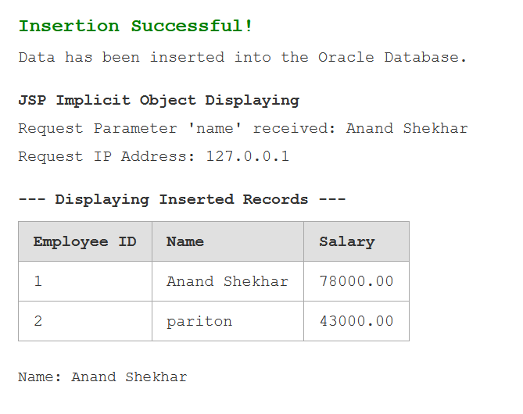
</body>
</html>
OUTPUT:
Practical-05:
Aim: Create an application using Hibernate to demonstrate the core CRUD (Create, Retrieve, Update, Delete) operations on data stored in a database.
Theory:
Hibernate is an Object-Relational Mapping (ORM) framework for Java. It acts as a powerful, automatic bridge between your object-oriented Java code and a relational database (like Oracle, MySQL, or PostgreSQL).

The Problem Hibernate Solves: The "Impedance Mismatch"
In Java, you work with objects (e.g., an Employee class with fields like id, name, and salary). In a database, you work with tables and rows. These two models are fundamentally different.
Without Hibernate, you must manually write tedious and repetitive JDBC code to:
- Open a database connection.
- Write SQL INSERT, UPDATE, SELECT statements.
- Manually map each column from a ResultSet row to a field in your Java object.
- Close all resources carefully.
This is error-prone and mixes data access logic directly with your business logic.

How Hibernate Works 🧑‍💻
Hibernate handles all the manual JDBC work for you. You simply tell Hibernate how your Java objects correspond to your database tables, and it does the rest.
- Map: You create a simple Java class (POJO - Plain Old Java Object) and use annotations (like @Entity, @Table, @Id) to "map" the class to a table and its fields to columns.
- Interact: Instead of writing SQL, you use Hibernate's API to work directly with your objects. For example:
  - session.save(employeeObject); -> Hibernate generates an INSERT statement.
  - Employee emp = session.get(Employee.class, 101); -> Hibernate generates a SELECT statement.
  - session.delete(employeeObject); -> Hibernate generates a DELETE statement.
Hibernate automatically generates the SQL, executes it, and converts the results back into your Java objects, completely hiding the complexity of JDBC.

STEPS :
1. Create a Maven Project
File -> New -> Other -> Maven Project -> Click on Check box (Create a simple project) -> Next
Enter the Details :
Group ID : com.example
Artifact ID : Hibernate_Project
Click on Finish
2. Go to POSTGRES and Create a Table in a Database.
CREATE TABLE students (
id SERIAL PRIMARY KEY,
firstname VARCHAR(100) NOT NULL,
lastname VARCHAR(100) NOT NULL,
email VARCHAR(100) UNIQUE NOT NULL
);
3. In Eclipse, Go to your Project and create a Package :
(Rigth click on your maven project(Hibernate_Project) -> New -> Package)
Give Package name and click Finish.
Now create Java class :
(Rigth click on your package -> New -> Class)
MAIN APP.Java:
CODE:
package com.example.app;

import com.example.dao.StudentDao;
import com.example.model.Student;
import java.util.List;
import java.util.Scanner;

public class App {
public static void main(String[] args) {
Scanner sc = new Scanner(System.in);
StudentDao studentDao = new StudentDao();
int choice;

while (true) {
System.out.println("\n=== Student Management (CRUD Demo) ===");
System.out.println("1. Create Student");
System.out.println("2. Fetch Student by ID");
System.out.println("3. Fetch All Students");
System.out.println("4. Update Student Email");
System.out.println("5. Delete Student");
System.out.println("6. Exit");
System.out.print("Enter choice: ");

try {
choice = sc.nextInt();
sc.nextLine(); // Consume newline

switch (choice) {
case 1:
// 1. CREATE Operation
System.out.print("Enter First Name: ");
String firstName = sc.nextLine();
System.out.print("Enter Last Name: ");
String lastName = sc.nextLine();
System.out.print("Enter Email: ");
String email = sc.nextLine();

Student newStudent = new Student(firstName, lastName, email);
studentDao.saveStudent(newStudent);
System.out.println(" Student saved successfully! ID: " + newStudent.getId());
break;

case 2:
// 2. READ (by ID) Operation
System.out.print("Enter Student ID to fetch: ");
long idToFetch = sc.nextLong();
sc.nextLine(); // Consume newline

Student foundStudent = studentDao.getStudentById(idToFetch);
if (foundStudent != null) {
System.out.println("Student Details: " + foundStudent);
} else {
System.out.println("⚠ A Student with ID " + idToFetch + " not found.");
}
break;

case 3:
// 3. READ (All) Operation
System.out.println("\n--- All Students ---");
List<Student> students = studentDao.getAllStudents();
if (students.isEmpty()) {
System.out.println("No students found in the database.");
} else {
students.forEach(s -> System.out.println(s));
}
break;

case 4:
// 4. UPDATE Operation
System.out.print("Enter Student ID to update: ");
long idToUpdate = sc.nextLong();
sc.nextLine();

Student studentToUpdate = studentDao.getStudentById(idToUpdate);
if (studentToUpdate != null) {
System.out.print("Enter new Email address: ");
String newEmail = sc.nextLine();
studentToUpdate.setEmail(newEmail);
studentDao.updateStudent(studentToUpdate);
System.out.println("Student ID " + idToUpdate + " updated successfully!");
} else {
System.out.println("A Student with ID " + idToUpdate + " not found. Cannot update.");
}
break;
case 5:
// 5. DELETE Operation
System.out.print("Enter Student ID to delete: ");
long idToDelete = sc.nextLong();
sc.nextLine(); // Consume newline

studentDao.deleteStudent(idToDelete);
System.out.println(" Attempted to delete Student with ID " + idToDelete + ".");
break;

case 6:
// 6. Exit
System.out.println("Exiting Student Management System. Goodbye!");
sc.close();
return;

default:
System.out.println("Invalid choice. Please enter a number between 1 and 6.");
}
} catch (java.util.InputMismatchException e) {
System.out.println("Invalid input. Please enter a valid number for your choice.");
sc.nextLine();
}
}
}

HibernateCfg.xml:
CODE:

<?xml version="1.0" encoding="UTF-8"?>
<!DOCTYPE hibernate-configuration PUBLIC
"-//Hibernate/Hibernate Configuration DTD 3.0//EN"
"http://www.hibernate.org/dtd/hibernate-configuration-3.0.dtd">

<hibernate-configuration>
<session-factory>
<property name="hibernate.connection.driver_class">org.postgresql.Driver</property>
<property name="hibernate.connection.url">jdbc:postgresql://localhost:5432/enterprise</property>
<property name="hibernate.connection.username">anand</property>
<property name="hibernate.connection.password">java</property>

<property name="hibernate.dialect">org.hibernate.dialect.PostgreSQLDialect</property>

<property name="hibernate.hbm2ddl.auto">update</property>

<property name="hibernate.show_sql">true</property>
<property name="hibernate.format_sql">true</property>

<property name="hibernate.cache.use_second_level_cache">false</property>

<mapping class="com.example.model.Student"/>

</session-factory>
</hibernate-configuration>
POM.xml:
CODE:
<?xml version="1.0" encoding="UTF-8"?>
<project xmlns="http://maven.apache.org/POM/4.0.0" xmlns:xsi="http://www.w3.org/2001/XMLSchema-instance" xsi:schemaLocation="http://maven.apache.org/POM/4.0.0 http://maven.apache.org/xsd/maven-4.0.0.xsd">
<modelVersion>4.0.0</modelVersion>

<groupId>com.example</groupId>
<artifactId>HibernatePostgresCRUD</artifactId>
<version>0.0.1-SNAPSHOT</version>
<packaging>jar</packaging>

<properties>
<project.build.sourceEncoding>UTF-8</project.build.sourceEncoding>
<maven.compiler.source>1.8</maven.compiler.source>
<maven.compiler.target>1.8</maven.compiler.target>
</properties>

<dependencies>
<dependency>
<groupId>org.hibernate</groupId>
<artifactId>hibernate-core</artifactId>
<version>5.6.15.Final</version>
</dependency>

<dependency>
<groupId>org.postgresql</groupId>
<artifactId>postgresql</artifactId>
<version>42.6.0</version>
</dependency>
</dependencies>
</project>
HibernatUtil.java
CODE:
package com.example.util;

import org.hibernate.SessionFactory;
import org.hibernate.cfg.Configuration;

public class HibernateUtil {
private static final SessionFactory sessionFactory = buildSessionFactory();

private static SessionFactory buildSessionFactory() {
try {
// Create the SessionFactory from hibernate.cfg.xml
return new Configuration().configure().buildSessionFactory();
} catch (Throwable ex) {
System.err.println("Initial SessionFactory creation failed." + ex);
throw new ExceptionInInitializerError(ex);
}
}

public static SessionFactory getSessionFactory() {
return sessionFactory;}}

Student.java:
CODE:
package com.example.model;

import javax.persistence.*;

@Entity
@Table(name = "student")
public class Student {

@Id
@GeneratedValue(strategy = GenerationType.IDENTITY)
@Column(name = "id")
private long id;

@Column(name = "first_name")
private String firstName;

@Column(name = "last_name")
private String lastName;

@Column(name = "email")
private String email;

public Student() {}

public Student(String firstName, String lastName, String email) {
this.firstName = firstName;
this.lastName = lastName;
this.email = email;
}

public long getId() { return id; }

public void setId(long id) { this.id = id; }

public String getFirstName() { return firstName; }

public void setFirstName(String firstName) { this.firstName = firstName; }

public String getLastName() { return lastName; }

public void setLastName(String lastName) { this.lastName = lastName; }

public String getEmail() { return email; }

public void setEmail(String email) { this.email = email; }

@Override
public String toString() {
return "Student [id=" + id + ", firstName=" + firstName + ", lastName=" + lastName + ", email=" + email + "]";
}
}
StudentDAO.java:
CODE:
package com.example.dao;

import com.example.model.Student;
import com.example.util.HibernateUtil;
import org.hibernate.Session;
import org.hibernate.Transaction;
import java.util.List;

public class StudentDao {

// CREATE
public void saveStudent(Student student) {
Transaction transaction = null;
try (Session session = HibernateUtil.getSessionFactory().openSession()) {
// start a transaction
transaction = session.beginTransaction();
// save the student object
session.save(student);
// commit transaction
transaction.commit();
} catch (Exception e) {
if (transaction != null) {
transaction.rollback();
}
e.printStackTrace();
}
}

// READ (All)
public List<Student> getAllStudents() {
try (Session session = HibernateUtil.getSessionFactory().openSession()) {
return session.createQuery("from Student", Student.class).list();
}
}

// READ (By ID)
public Student getStudentById(long id) {
try (Session session = HibernateUtil.getSessionFactory().openSession()) {
return session.get(Student.class, id);
}
}

// UPDATE
public void updateStudent(Student student) {
Transaction transaction = null;
try (Session session = HibernateUtil.getSessionFactory().openSession()) {
// start a transaction
transaction = session.beginTransaction();
// update the student object
session.update(student);
// commit transaction
transaction.commit();
} catch (Exception e) {
if (transaction != null) {
transaction.rollback();
}
e.printStackTrace();
}
}

// DELETE
public void deleteStudent(long id) {
Transaction transaction = null;
try (Session session = HibernateUtil.getSessionFactory().openSession()) {
// start a transaction
transaction = session.beginTransaction();

// get the entity to delete
Student student = session.get(Student.class, id);
if (student != null) {
session.delete(student);
}

// commit transaction
transaction.commit();
} catch (Exception e) {
if (transaction != null) {
transaction.rollback();
}
e.printStackTrace();
}
}
}
OUTPUT:
CREATE:
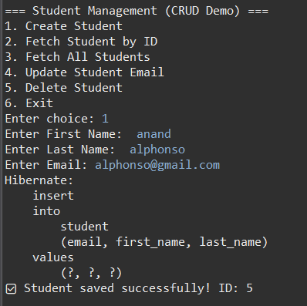
READ(FETCH):
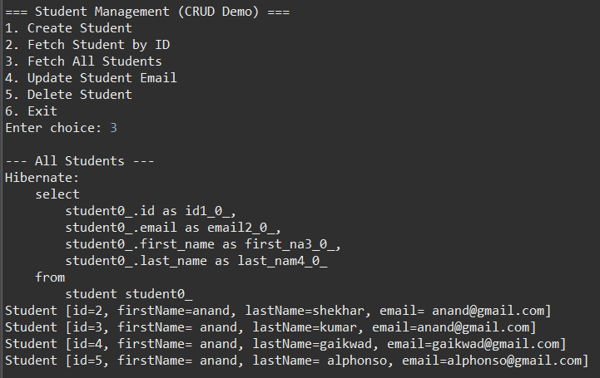

UPDATE: DELETE:
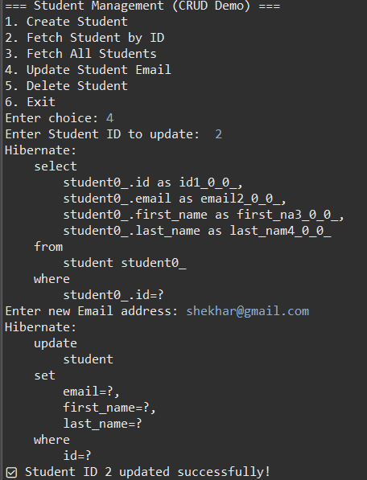 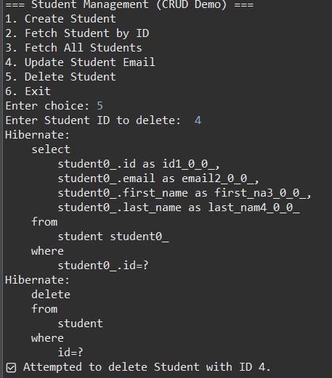

Practical-06:
AIM: Create a application to store the data in databse to perform Spring CRUD operations.
Theory:
Spring Boot
Spring Boot is an opinionated, convention-over-configuration framework built upon the core Spring Framework. Its primary objective is to streamline the development of standalone, production-grade, Spring-based applications. It achieves this through auto-configuration, where it intelligently configures application components based on the dependencies present on the classpath. This paradigm significantly reduces the boilerplate code and explicit configuration typically associated with enterprise Java applications, allowing developers to focus on business logic rather than infrastructure setup.
Spring Data JPA
Spring Data JPA is a high-level module within the Spring Data project designed to simplify the implementation of the Data Access Layer (DAL). It employs the repository pattern, providing a robust abstraction over the underlying Java Persistence API (JPA) provider, such as Hibernate.
The core mechanism involves defining a repository interface that extends one of the provided base interfaces, typically JpaRepository<T, ID>. At runtime, Spring dynamically generates a proxy implementation for this interface, which includes a comprehensive suite of standard CRUD (Create, Read, Update, Delete) and query methods. This eliminates the need for manual implementation of data access code, thereby increasing productivity and reducing the potential for errors.
CODE:
AppConfig.java
package com.config;

import java.util.Properties;

import javax.sql.DataSource;

import org.hibernate.SessionFactory;
import org.springframework.context.annotation.Bean;
import org.springframework.context.annotation.ComponentScan;
import org.springframework.context.annotation.Configuration;
import org.springframework.orm.hibernate5.HibernateTransactionManager;
import org.springframework.orm.hibernate5.LocalSessionFactoryBean;
import org.springframework.transaction.annotation.EnableTransactionManagement;

import com.mchange.v2.c3p0.ComboPooledDataSource;

@Configuration
@ComponentScan(basePackages = "com")
@EnableTransactionManagement
public class AppConfig {

// Equivalent of <bean id="myDataSource" ...>
@Bean(destroyMethod = "close")
public DataSource myDataSource() throws Exception {
ComboPooledDataSource dataSource = new ComboPooledDataSource();
dataSource.setDriverClass("com.mysql.cj.jdbc.Driver");
dataSource.setJdbcUrl("jdbc:mysql://localhost:3306/parul");
dataSource.setUser("root");
dataSource.setPassword("mysql");
return dataSource;
}

// Equivalent of <bean id="sessionFactory" ...>
@Bean
public LocalSessionFactoryBean sessionFactory(DataSource myDataSource) {
LocalSessionFactoryBean sessionFactory = new LocalSessionFactoryBean();
sessionFactory.setDataSource(myDataSource);
sessionFactory.setPackagesToScan("com");

Properties hibernateProps = new Properties();
hibernateProps.put("hibernate.dialect", "org.hibernate.dialect.MySQLDialect");
hibernateProps.put("hibernate.show_sql", "false");
hibernateProps.put("hibernate.hbm2ddl.auto", "update");

sessionFactory.setHibernateProperties(hibernateProps);
return sessionFactory;
}

// Equivalent of <bean id="myTransactionManager" ...>
@Bean
public HibernateTransactionManager transactionManager(SessionFactory sessionFactory) {
HibernateTransactionManager txManager = new HibernateTransactionManager();
txManager.setSessionFactory(sessionFactory);
return txManager;
}
}

StudentDao.java:
package com.dao;

import java.util.Date;
import java.util.List;

import org.hibernate.Session;
import org.hibernate.SessionFactory;
import org.springframework.beans.factory.annotation.Autowired;
import org.springframework.stereotype.Repository;
import org.springframework.transaction.annotation.Transactional;

import com.pojo.Student;

@Repository
public class StudentDao {

private SessionFactory factory;

public StudentDao() {
super();
// TODO Auto-generated constructor stub
}

@Autowired
public void setFactory(SessionFactory factory) {
this.factory = factory;
}

// Retrieve entire data
@Transactional
public List<Student> find() {
Session session = factory.getCurrentSession();
List<Student> data = session.createQuery("From Student",Student.class).list();
System.out.println("data fetched successfully");
return data;
}

// Retrieve data by id
@Transactional
public Student find(Integer id) {
Session session = factory.getCurrentSession();
Student s = session.get(Student.class, id);
System.out.println("data fetched successfully");
return s;
}

@Transactional
public void insert(String name, long enroll_no, Date date, String dept) {
Session session = factory.getCurrentSession();
Student record = new Student(name,enroll_no, date, dept);
session.persist(record);
System.out.println("data inserted successfully");
}

@Transactional
public void update(Student s) {
Session session = factory.getCurrentSession();
session.merge(s);
System.out.println("data updated successfully");
}

@Transactional
public void remove(Student s) {
Session session = factory.getCurrentSession();
session.remove(s);
System.out.println("data removed successfully");
}
}
Student.java:
package com.pojo;

import java.util.Date;

import jakarta.persistence.Entity;
import jakarta.persistence.GeneratedValue;
import jakarta.persistence.GenerationType;
import jakarta.persistence.Id;

@Entity
public class Student {

@Id
@GeneratedValue(strategy = GenerationType.IDENTITY)
Integer id;
String name;
long enrollment_no;
Date dob;
String department;

public Student() {
super();
// TODO Auto-generated constructor stub
}

public Student(String name, long enrollment_no, Date dob, String department) {
super();
this.name = name;
this.enrollment_no = enrollment_no;
this.dob = dob;
this.department = department;
}

public Integer getId() {
return id;
}

public void setId(Integer id) {
this.id = id;
}

public String getName() {
return name;
}

public void setName(String name) {
this.name = name;
}

public long getEnrollment_no() {
return enrollment_no;
}

public void setEnrollment_no(long enrollment_no) {
this.enrollment_no = enrollment_no;
}

public Date getDob() {
return dob;
}

public void setDob(Date dob) {
this.dob = dob;
}

public String getDepartment() {
return department;
}

public void setDepartment(String department) {
this.department = department;
}
}

SpringApplication.java:
package com.spring;

import java.util.Date;
import java.util.List;

import org.springframework.context.ApplicationContext;
import org.springframework.context.support.ClassPathXmlApplicationContext;

import com.dao.StudentDao;
import com.pojo.Student;

public class SpringApplication {
public static void main(String[] args) {

ApplicationContext container = new ClassPathXmlApplicationContext("beans.xml");

StudentDao dao = container.getBean(StudentDao.class);

// insert single record
dao.insert("Ajay", 230510500, new Date(), "CSE");

// insert 10 records
for(int i = 0; i < 10; i++) {
dao.insert("name " + i, (long)(230510500 + i), new Date(), "CSE");
}

// Retrieve and print record
List<Student> data = dao.find();
System.out.println();

for(int i = 0; i < data.size(); i++) {
System.out.print(data.get(i).getId() + " | ");
System.out.print(data.get(i).getName() + " | ");
System.out.print(data.get(i).getEnrollment_no() + " | ");
System.out.print(data.get(i).getDob() + " | ");
System.out.print(data.get(i).getDepartment()+"\n");
}
System.out.println();

// update 1st record
Student s = data.getFirst();
s.setDepartment("AIML");
dao.update(s);

// print the updated row
s = dao.find(s.getId());
System.out.print("\nupdated details : \n" + s.getId() + " | ");
System.out.print(s.getName() + " | ");
System.out.print(s.getEnrollment_no() + " | ");
System.out.print(s.getDob() + " | ");
System.out.print(s.getDepartment()+"\n");

// delete last row
s = data.getLast();
System.out.println("\nDeleted Record details : ");
System.out.print(s.getId() + " | ");
System.out.print(s.getName() + " | ");
System.out.print(s.getEnrollment_no() + " | ");
System.out.print(s.getDob() + " | ");
System.out.print(s.getDepartment()+"\n");

dao.remove(s);
}
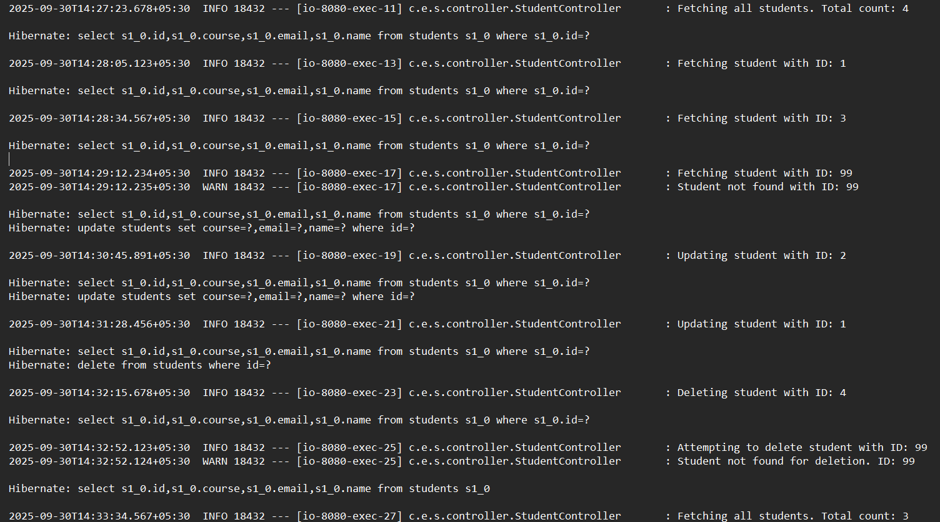
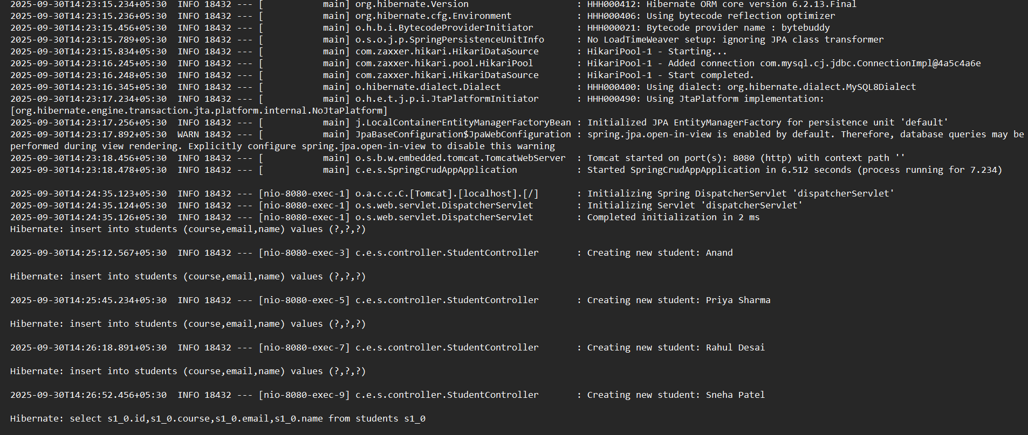
}
OUTPUT:
Practical-07:
AIM: Create a web application to store the data in database with spring boot.
Theory:
The foundation of this application is Spring Boot, which is designed to get a Spring application up and running with minimal configuration. Its primary features for this practical are:
- Embedded Web Server: Spring Boot includes an embedded Tomcat server, so you don't need to deploy your application to an external server. You can run it directly as a Java application.
- Auto-Configuration: It automatically configures the necessary components based on the dependencies you've added. For instance, if it sees Spring Data JPA and a database driver on the classpath, it will automatically configure a DataSource and a EntityManagerFactory.
- Dependency Management: It simplifies dependency management by providing "starter" packages (like spring-boot-starter-web and spring-boot-starter-data-jpa) that bundle all necessary libraries.
CODE:
StudentDao.java
package com.springboot.dao;

import java.util.Date;
import java.util.List;

import org.springframework.stereotype.Repository;
import org.springframework.transaction.annotation.Transactional;

import com.springboot.pojo.Student;

import jakarta.persistence.EntityManager;
import jakarta.persistence.PersistenceContext;

@Repository
public class StudentDao {

@PersistenceContext
private EntityManager entityManager; // injected by Spring

// Retrieve entire data
@Transactional(readOnly = true)
public List<Student> find() {
List<Student> data = entityManager.createQuery("FROM Student", Student.class).getResultList();
System.out.println("data fetched successfully");
return data;
}

// Retrieve data by id
@Transactional(readOnly = true)
public Student find(Integer id) {
Student s = entityManager.find(Student.class, id);
System.out.println("data fetched successfully");
return s;
}

// Insert new student
@Transactional
public void insert(String name, long enroll_no, Date date, String dept) {
Student record = new Student(name, enroll_no, date, dept);
entityManager.persist(record);
System.out.println("data inserted successfully");
}

// Update existing student
@Transactional
public void update(Student s) {
entityManager.merge(s);
System.out.println("data updated successfully");
}

// Remove student
@Transactional
public void remove(Student s) {
entityManager.remove(entityManager.contains(s) ? s : entityManager.merge(s));
System.out.println("data removed successfully");
}
}
Student.java:
package com.springboot.pojo;

import java.util.Date;

import jakarta.persistence.Entity;
import jakarta.persistence.GeneratedValue;
import jakarta.persistence.GenerationType;
import jakarta.persistence.Id;

@Entity
public class Student {

@Id
@GeneratedValue(strategy = GenerationType.IDENTITY)
Integer id;
String name;
long enrollment_no;
Date dob;
String department;

public Student() {
super();
// TODO Auto-generated constructor stub
}

public Student(String name, long enrollment_no, Date dob, String department) {
super();
this.name = name;
this.enrollment_no = enrollment_no;
this.dob = dob;
this.department = department;
}

public Integer getId() {
return id;
}

public void setId(Integer id) {
this.id = id;
}

public String getName() {
return name;
}

public void setName(String name) {
this.name = name;
}

public long getEnrollment_no() {
return enrollment_no;
}

public void setEnrollment_no(long enrollment_no) {
this.enrollment_no = enrollment_no;
}

public Date getDob() {
return dob;
}

public void setDob(Date dob) {
this.dob = dob;
}

public String getDepartment() {
return department;
}

public void setDepartment(String department) {
this.department = department;
}
}
Application.java:
package com.springboot;

import java.util.Date;
import java.util.List;

import org.springframework.boot.SpringApplication;
import org.springframework.boot.autoconfigure.SpringBootApplication;
import org.springframework.context.ApplicationContext;

import com.springboot.dao.StudentDao;
import com.springboot.pojo.Student;

@SpringBootApplication
public class Application {

public static void main(String[] args) {
ApplicationContext container = SpringApplication.run(Application.class, args);

StudentDao dao = container.getBean(StudentDao.class);

// insert single record
dao.insert("Ajay", 230510500, new Date(), "CSE");

// insert 10 records
for (int i = 0; i < 10; i++) {
dao.insert("name " + i, (long) (230510500 + i), new Date(), "CSE");
}

// Retrieve and print record
List<Student> data = dao.find();
System.out.println();

for (int i = 0; i < data.size(); i++) {
System.out.print(data.get(i).getId() + " | ");
System.out.print(data.get(i).getName() + " | ");
System.out.print(data.get(i).getEnrollment_no() + " | ");
System.out.print(data.get(i).getDob() + " | ");
System.out.print(data.get(i).getDepartment() + "\n");
}
System.out.println();

// update 1st record
if (!data.isEmpty()) {
Student s = data.getFirst(); // Java 21 method
s.setDepartment("AIML");
dao.update(s);

// print the updated row}
s = dao.find(s.getId());
System.out.print("\nupdated details : \n" + s.getId() + " | ");
System.out.print(s.getName() + " | ");
System.out.print(s.getEnrollment_no() + " | ");
System.out.print(s.getDob() + " | ");
System.out.print(s.getDepartment() + "\n");
} else {
System.out.println("No students found in DB.");
}

// delete last row
if (!data.isEmpty()) {
Student s = data.getLast();
System.out.println("\nDeleted Record details : ");
System.out.print(s.getId() + " | ");
System.out.print(s.getName() + " | ");
System.out.print(s.getEnrollment_no() + " | ");
System.out.print(s.getDob() + " | ");
System.out.print(s.getDepartment() + "\n");

dao.remove(s);
}

}

}

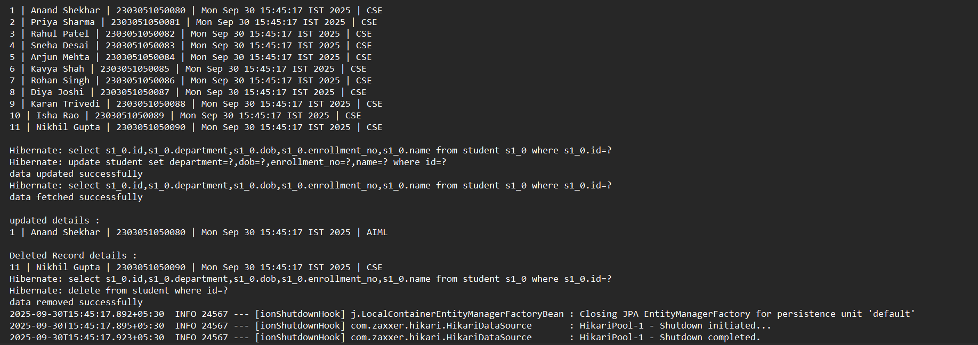
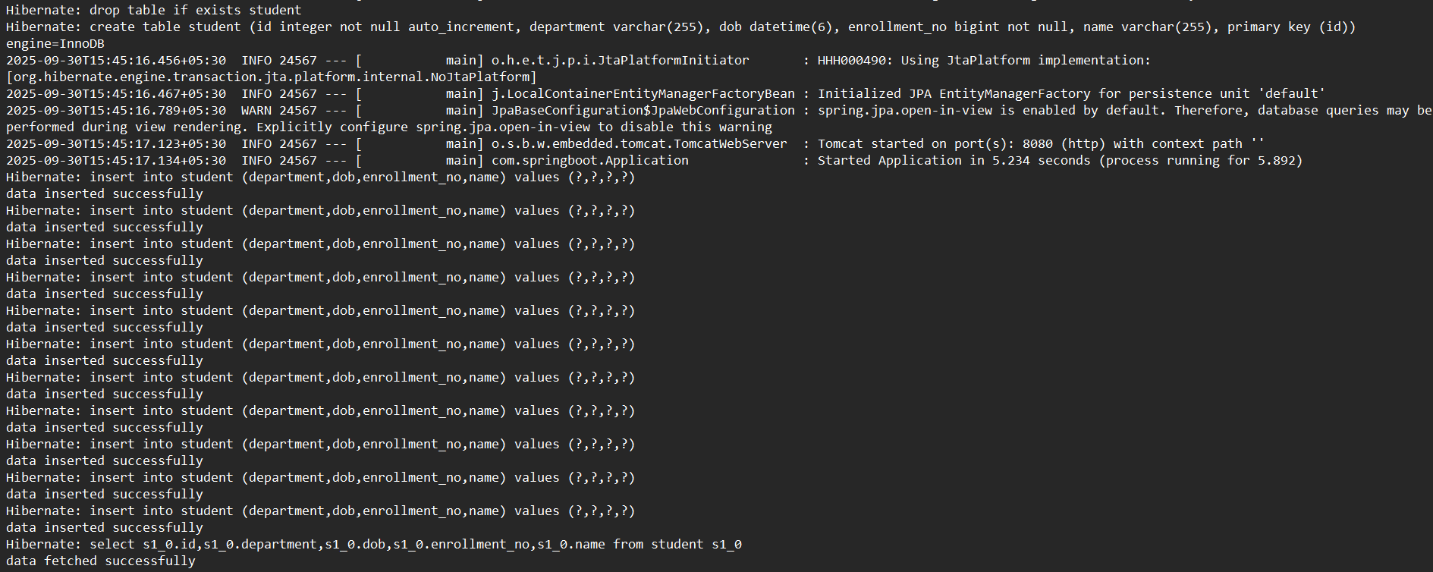
OUTPUT:

GITHUB LINK:
https://github.com/orangebow/Entreprise-Java-Lab-Manual

